Software Project Management Plan

Ka Lai

Towson University

COSC 412

Scope of the project:

The scope of the project is to create a web application that can store user’s record of their spending, and display the total sum of the spending.

Table of Content:

Part 1: Introduction

1.1 Project Overview

1.2 Project Deliverables

1.3 Reference Materials

Part 2: Technical Process

2.1 Methods, Tools, and Techniques

2.2 Software Documentation

2.3 Project Support Functions

2.4 Work Break down structure

2.5 Gannt Chart Schedule

Part 1: Introduction

1.1 Project Overview:

The project is a web application that stores user’s budget items in a list and stores the information in a cloud-based web server. The application also has functionalities such as an input form for users to create a spend record, a list of all the users spend records for the users to read, an update function for users to update any record in the displayed list and a delete function for users to delete any record in the displayed list with a button.

1.2 Project Deliverables:

|  |  |  |
| --- | --- | --- |
| Item Name | Description | Place to deliver |
| Link of web application | Web application with a domain name | Blackboard |
| Requirements and Use Case | A document about the web application’s function and how users interact with it | GitHub repository and Blackboard |
| Software Project Management Plan | A document about the detailed plan of the project | GitHub repository and blackboard |
| Tool Selection | A document about the tool used in the project | GitHub repository and Blackboard |

1.3 Reference Materials

https://docs.atlas.mongodb.com/

https://www.tutorialspoint.com/nodejs/index.htm

https://auth0.com/docs/

https://getbootstrap.com/docs/4.5/getting-started/download/

Part 2: Technical Process

2.1 Methods, Tools, and Techniques

Tools used in the project are MongoDB Atlas, Node.js and authentication library. The techniques are using dependencies in NPM library to implement server side and using template language to handle client-side display.

2.2 Software Documentation

The documentation plan is to document every function in my web application. I will list the function with the specification of node.js dependency that I am using.

2.3 Project Support Functions

The validation plan is that validating the program once I complete one feature of the web application. I will validate the part of the program with the rest of the other parts of the program.

2.4 Work Break down structure

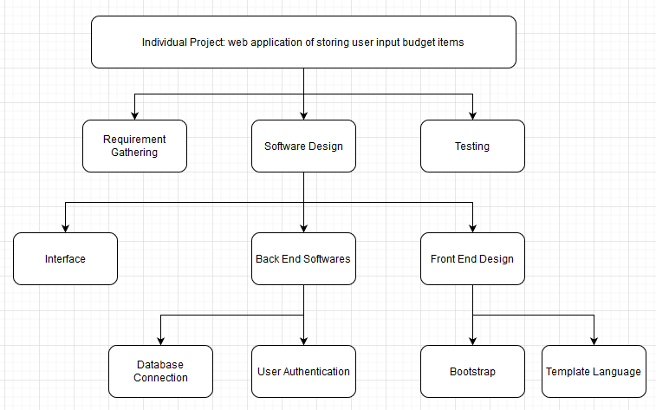

2.5 Gannt Chart Schedule

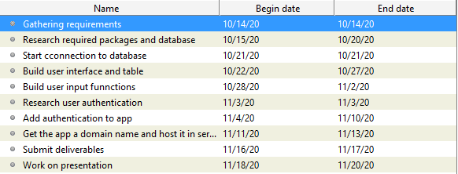

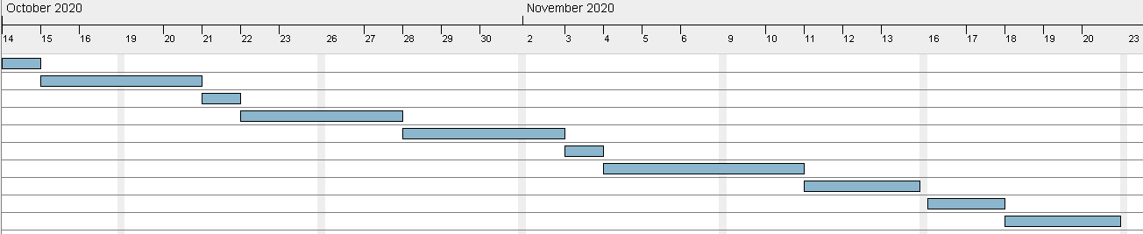

Milestones:

|  |  |
| --- | --- |
| Milestone Description | Date to be completed |
| A final build of the program | 11/9/20 |
| A web App with domain name | 11/13/20 |
| A completed presentation | 11/20/20 |